TICKET RAISE AND POD CHECK IN DTDC
Step – 1:
Go to DTDC workspace - https://workspace.dtdc.com/
Username - HF2307, Password - Kamal@1234
STEP – 2:
Click limitless and login there.
Username - DTDCEXP\HF2307, Password - Kamal@1234
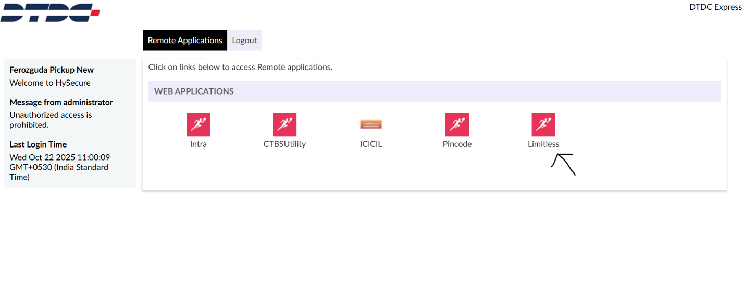
STEP – 3:
Go to Tracking, then press Live Tracking.
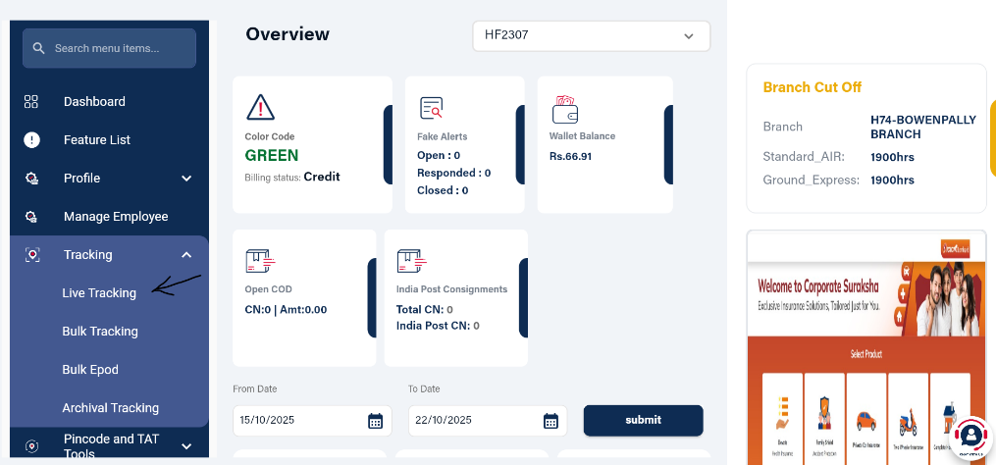
STEP – 4:
Enter the consignment number, then track.
STEP – 5:
After tracking, this page will appear, click on the ticket icon to raise ticket.
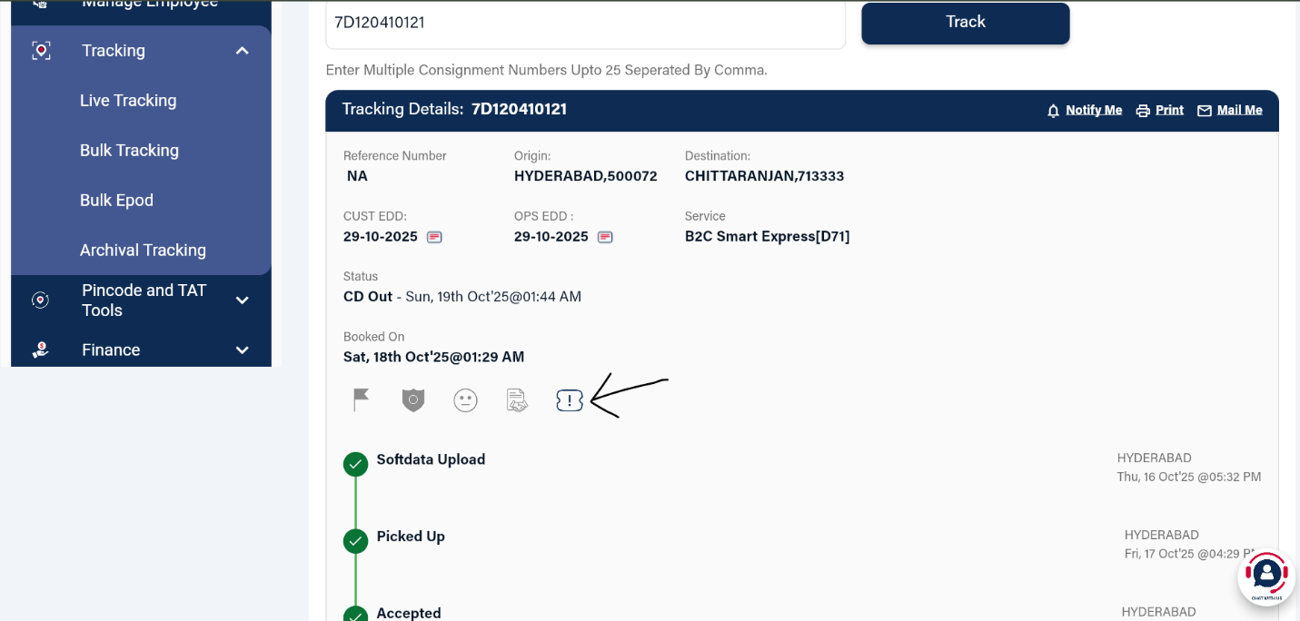
STEP – 6:
Click raise a query and fill up the necessary details.
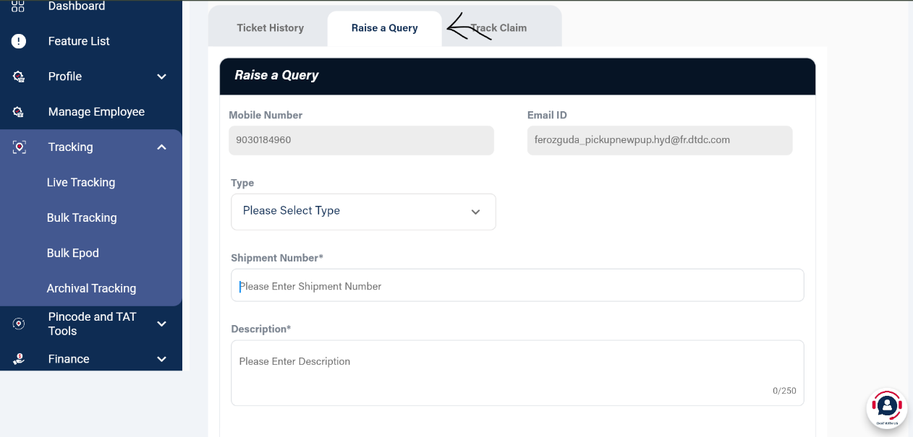
STEP – 7:
Click submit.
STEP – 8:
To check POD, go to tracking page and click on tracking history and press Document & Images. If order is not delivered yet, no POD will be there.
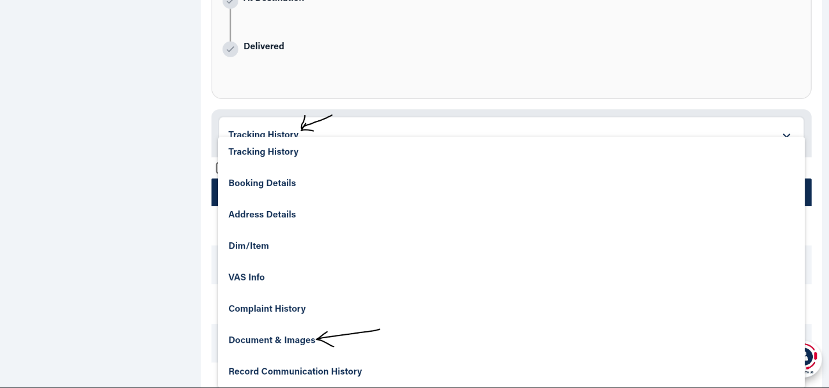
** To track, tracking history below can be checked**
